ASD ‘Service Spotlight’ Profile recordings

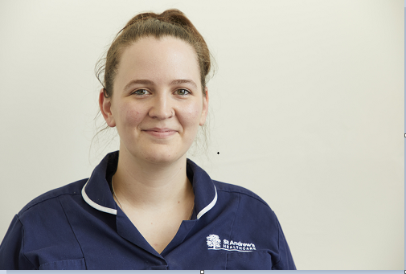

Jennifer Mytton – ASD-LD Specialist Nurse

Your experience in mental health:
I qualified as a Learning Disability Nurse about 10 years ago. Since then I have spent my career in and out of different services. This has included different experiences in the community, in secure services, mental health and learning disability services, but mainly surrounding autism and LD. I have a masters in Autism.

What is a Specialist Nurse?
My role as a Specialist Nurse is to support the wider nursing team. Within the ASD/LD division, I support nurses and the clinical nurse leads, as well as the nurse managers to provide clinical oversight. I am responsible for making sure that we are addressing a patient's needs with the most up-to-date evidence-based practices. My role ensures that we are achieving the goals that we need to achieve. Our outcomes are measured so that we can show the great work that we are doing.

What are the challenges of your role?
The biggest challenge in my role this year would have to be Covid-19. It has been quite difficult to work towards our patients goals with the struggles around Covid-19 that we have had. It has been very nice to see us pull together as a team through that struggle. We have still managed to work hard with our patients to continue to allow them to successfully discharge during this period.

What you most enjoy about your role?
The thing I enjoy most about my role is spending time with the patients. They are the reason that we are here. They make the job the most interesting. I had much rather be sat with them than on my computer. Every day is different. They present a variety of things. Just when you think you have seen everything, they come up with something else. They present with something different and we then have to be creative about how we manage that. That is the challenge but it is a fun challenge to have.

What is a typical patient presentation within our Specialist ASD inpatient services?
We support adults with a diagnosis of learning disability or autism depending on the ward. Many patients have additional complex mental health needs and some have complex physical health care needs. Patients often have difficulties with their communication, social interactions and sensory needs.

What are the main interventions used?
The key interventions that we use for our patients include a wide variety of input from lots of different professionals, ranging from occupational therapy to psychotherapy through to sensory integration work. We also have psychology input, psychiatry input and a great big nursing team of qualified nurses and HCAs.

From a nursing perspective, how do we support patients with ASD?
As nurses, we support our patients with ASD in their triad of impairments. The communication issues, the sensory integration issues and the social interaction issues.

That can include things like using tools such as a ‘now and next board’ so that our patients do not become overwhelmed with what is going to happen throughout the day. We tell them what we are going to do now, and then we can very clearly tell them what is coming next. It ends there, so it is quite simple for them. It can provide a clear structure for the day, the whole day. We can say this is what is going to happen. There is no surprises. Change is minimal. As much as we cannot change things throughout the day, we will not, because they can find that quite distressing.

We also adapt our environment on the ward so we are quieter throughout the building. We close our doors quietly, because loud noises can trigger incidences for our patients, as they will become overwhelmed by the sensory feedback. We can change the lighting within our wards. We put in different lighting in some of our patients bedrooms, at their request, because it helps them.

Could you give us an example of a patient who you have helped as part of a multi-disciplinary team?
We currently have a Gentleman in a medium secure learning disability ward. We are reintegrating him from an extra care area, which is an area away from the communal ward. He was placed there because of some of the complex needs that he had. This included difficulties around other people and on the ward. We have worked closely as a clinical team with occupational therapy who have provided some meaningful activity for him. We have worked with the nursing team who have provided a real structure and routine to his day. We have also had some psychology input and some sensory input. He now has a safety pod, which is a sensory tool that we can use for him. He is now out, back on the ward, and he is looking to discharge from medium secure. He has come a long way from where he was.

As an ASD healthcare service, how are we working to ensure quality?
We are signed up to the National Autistic Society Accreditation Program. We have just had a review with some positive feedback and some constructive feedback about where we can move forward. They are excited about the service that we could potentially provide and we are excited to work with them.

As a nursing team how do you support that next step out of hospital for patients with ASD?
As a nursing team, our main goal is to get people out of hospital. We want them here for the least amount of time possible so we try to work closely with community teams and providers to be able to provide them with as much information to find the most appropriate placement for that person. That could be back home, it could be their own property, it could be a communal living space with nursing support 24/7. It completely depends on the person. We try to provide the next provider with as much useful information as we can so that between us there is a plan that works for that person and can transition with them.

Can you share an interesting or fun fact about yourself?
When I am not at work and I am not here at St Andrew’s I like to watch really rubbish telly, mainly RuPaul's Drag Race. RuPaul's a way of calming down, disengaging from the day. Things can get quite tough at work. It is a challenging role, so it is a good way to recharge.

